**Project Interpreter**

You need an interpreter to run any of the python programs and to make sure that errors are noted while scripting.

You have 2 choices 1) use a local version of python 2) use a remote version of python.

#1 To use a local version:

load and install python locally ([www.python.org](http://www.python.org))

Remember WHERE you installed it

#2 install/Run Pycharm (similar to below)

Licence info

http://slcibhf.us.oracle.com:1111/

http://10.242.15.96:1111/

Choose settings -> Project -> Project Interpreter.

Under the choice for the interpreter, it’ll be blank. Choose Show all,

Then add a new interpreter with the “+” symbol in the upper right.

#3 to use a remote version:

This is the thing that enables you to use the Python version ON a host in OCCN for example rather than what’s loaded locally

File -> Settings -> project -> Project Interpreter

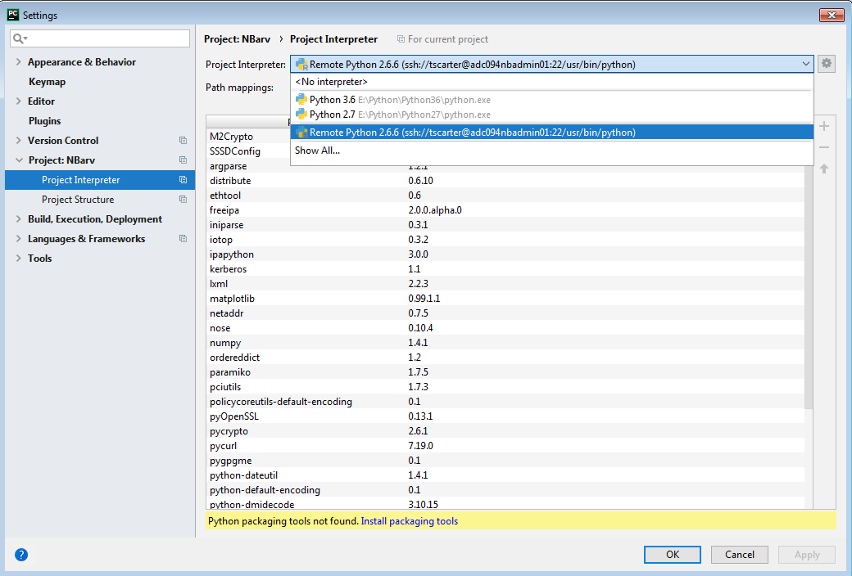

To set up the first time or to fix passwords, Select Show All

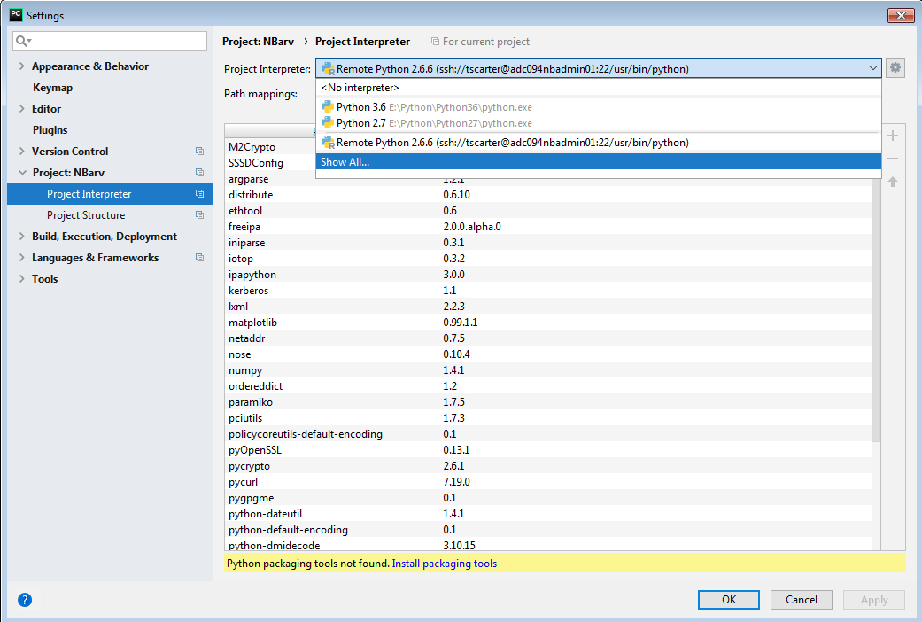

Add the first time

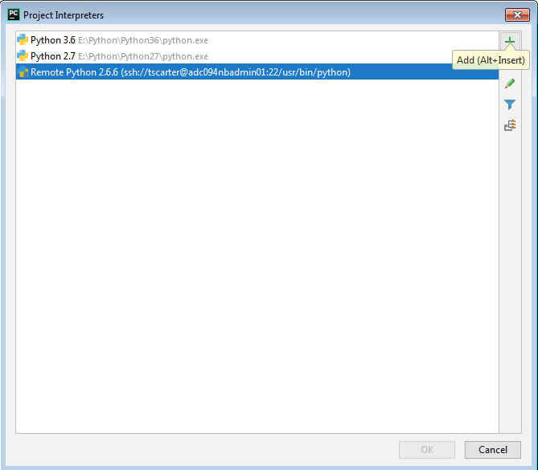

Or edit for updating password

Fill in the connection information

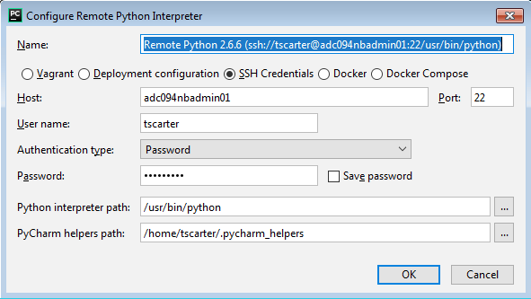

**Remote Host Syncronization**

remote host for testing is root@adc094nbadmin01 /usr/openv/scripts/

Source Synchronizer is what allows auto scp feature from your local system to the test host

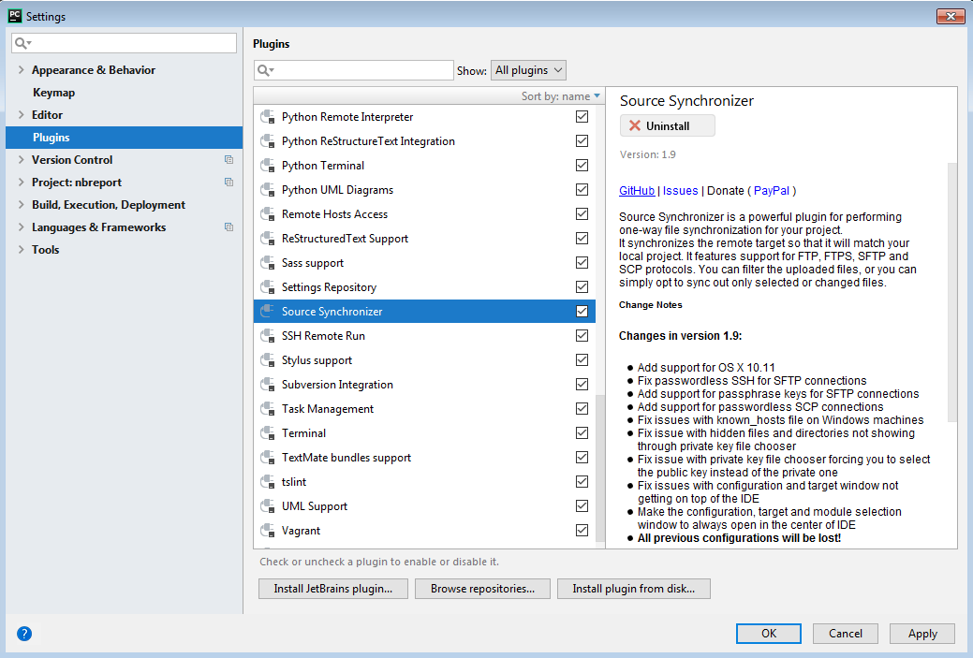

Download and install and how to

<https://plugins.jetbrains.com/plugin/7374-source-synchronizer>

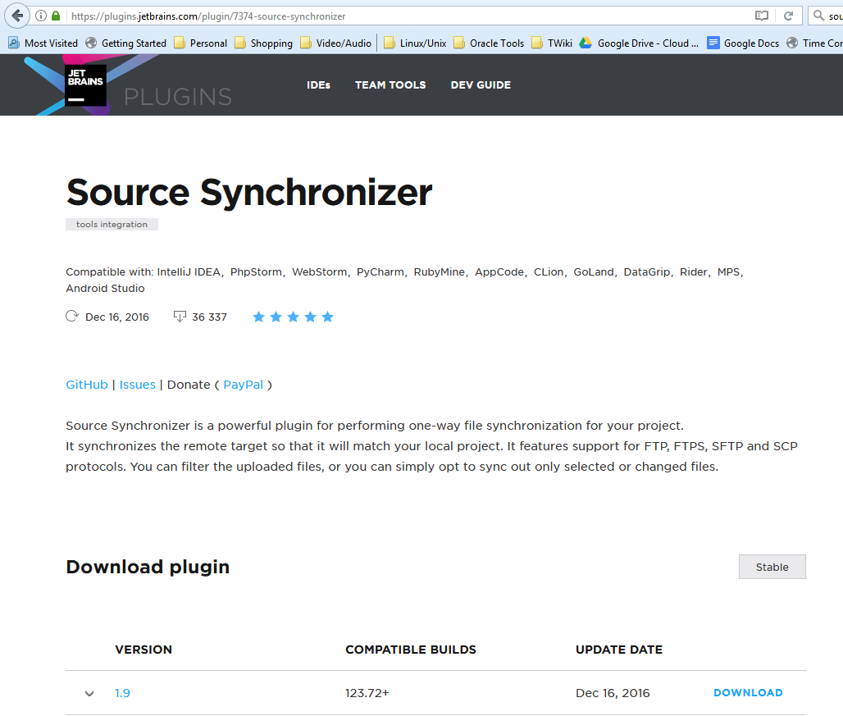

Tools -> Sourcesync

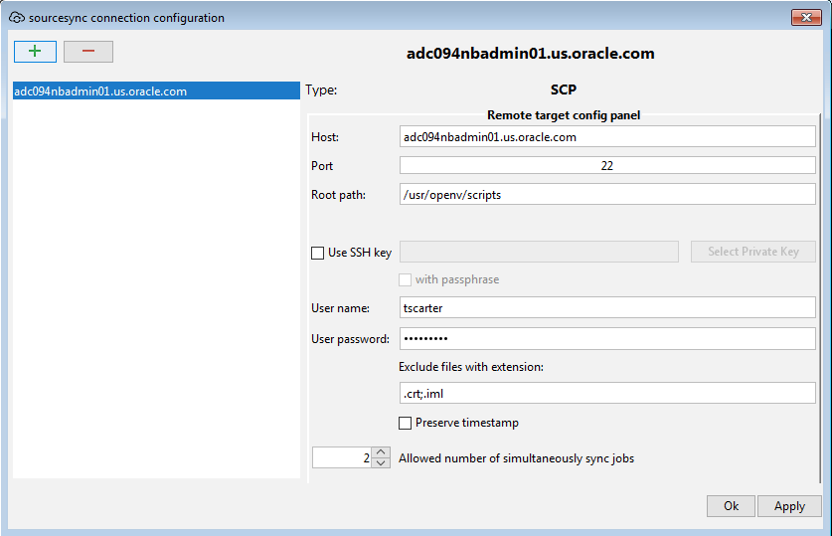

Right click on the project

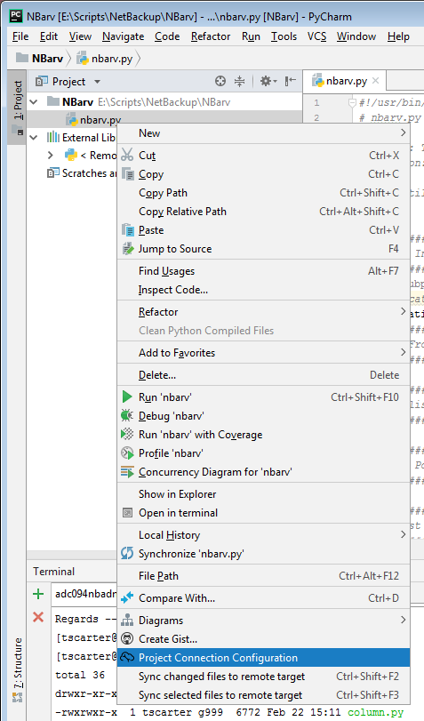

Choose remote connection

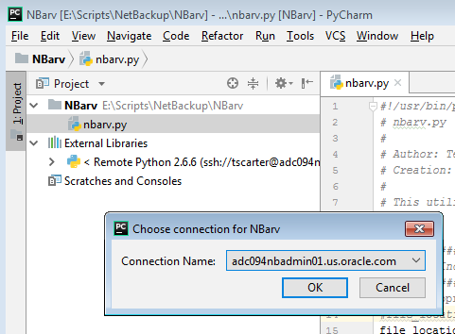

Sync files up to the remote connection

right click on the file

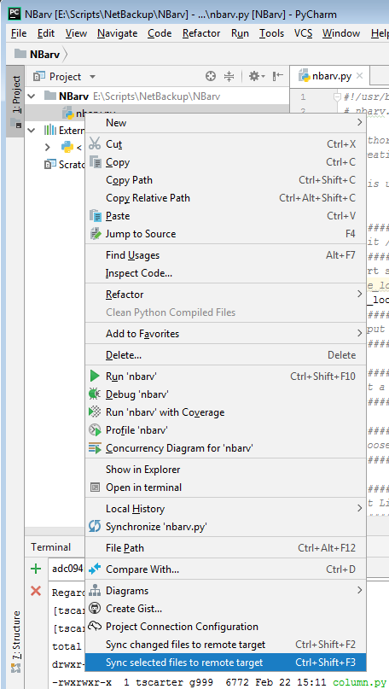

File is uploaded

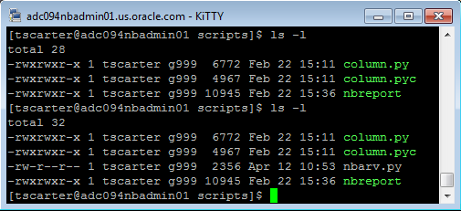

chmod to make it runnable

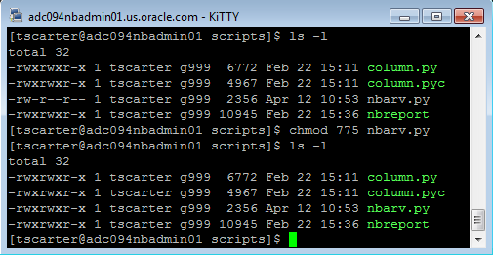

**Issue** – CR/LF differences

[tscarter@adc094nbadmin01 scripts]$ ./nbarv.py

-bash: ./nbarv.py: /usr/bin/python^M: bad interpreter: No such file or directory

Solution:

The carriage returns are different on Windows and Linux (Notice the ^M)

<https://intellij-support.jetbrains.com/hc/en-us/community/posts/205801439-Unix-LF-vs-Windows-CRLF-line-endings-how-to-control->

*“PyCharm always saves files with the same line endings for every line. It keeps the line endings that were used in the file when opening, and if a file has mixed line endings, it uses the line ending from the last line of the file. At the moment this behavior is not configurable.”*

Start with a file that is scp’d over from the linux box, a “seed” file if you will. Then all editing will continue with the same CR/LF configuration as the original.

**Issue – Keyboard shortcut change**

<https://www.jetbrains.com/help/pycharm/configuring-keyboard-and-mouse-shortcuts.html>

I had an issue where I had already mapped F3 to something else. The remote sync wants to use it

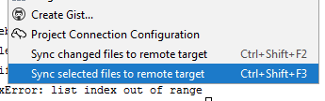

File -> Settings -> Keymap -> (the section I wanted to change) Plug-ins -> Source Synchronizer -> Sync this file…

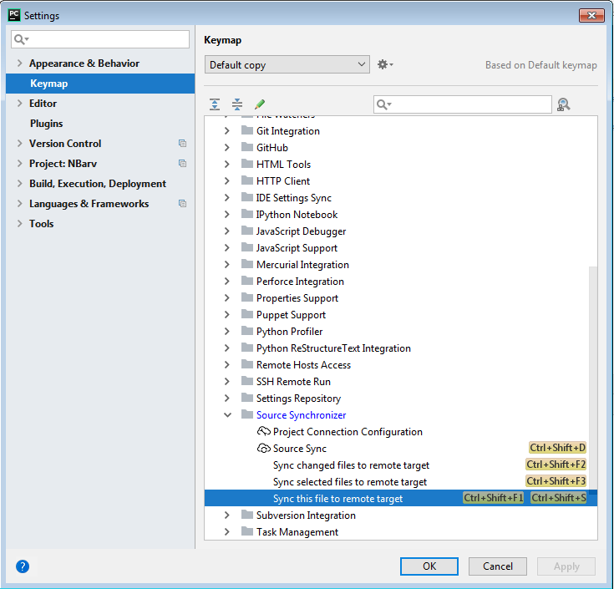

Add keyboard shortcut

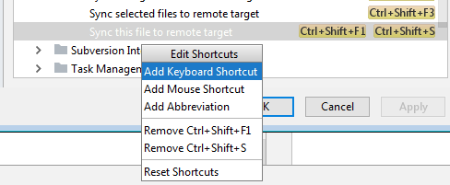

Just type in the keyboard shortcut you’ld like instead

